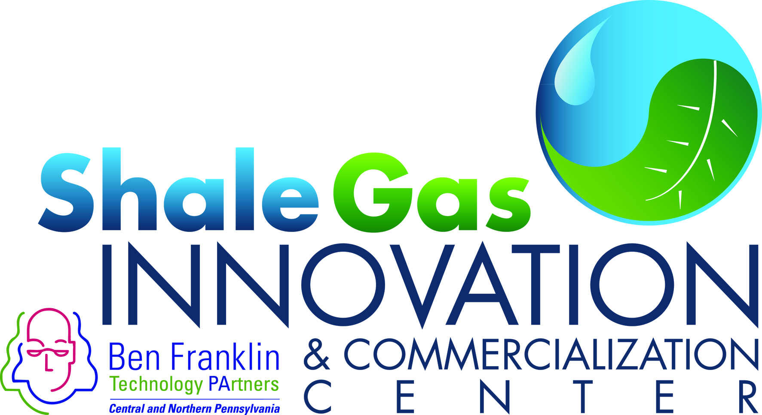
FOR IMMEDIATE RELEASE May 11, 2017
For further information:
Bill Hall/ Director
Shale Gas Innovation & Commercialization Center
814-933-8203
billhall@psu.edu

Three Winners Announced at 2017 Shale Gas Innovation Contest Finals Event

PITTSBURGH, PA –On May 9th in Pittsburgh during the 6th Annual Shale Gas Innovation Contest the following three companies each walked away with a winner’s check for $20,000:
- Frontier Natural Resources, Inc. - Commercialized the first small scale natural gas liquefaction facility in Pennsylvania utilizing natural gas from an adjacent gathering and compression facility. Second site under development uses stranded natural gas, opening opportunities across the state and nation.
- PetroMar Technologies, Inc. – Commercializing FracView™, a low-cost LWD borehole imaging tool utilizing advanced dynamically focused acoustic transducer technology to obtain a very high resolution acoustic borehole image in any oil/synthetic liquid or synthetic) mud system
- Sensor Networks, Inc. - Offering product line of permanently installed battery powered ultrasonic sensors, providing remote, wireless data collection of critical piping infrastructure's wall thickness
In addition to the three winners, a fourth technology submitted by the Department of Energy’s National Energy Technology Laboratory (NETL) by Kelly Rose, Technology Geology & Geospatial Researcher, was highly praised by the contest judges and attendees, and was named the contest’s Innovative R&D Winner. The summary of that technology follows:
- NETL - Developed a cost effective and near real-time early kick detection system that leverages data obtained from logging while drilling, measurement while drilling, or seismic while drilling signals to provide an early warning before the kick ascends to the rig floor
NETL is seeking partners to continue demonstrate and validate the technology, and a potential licensing partner to commercialize the technology.
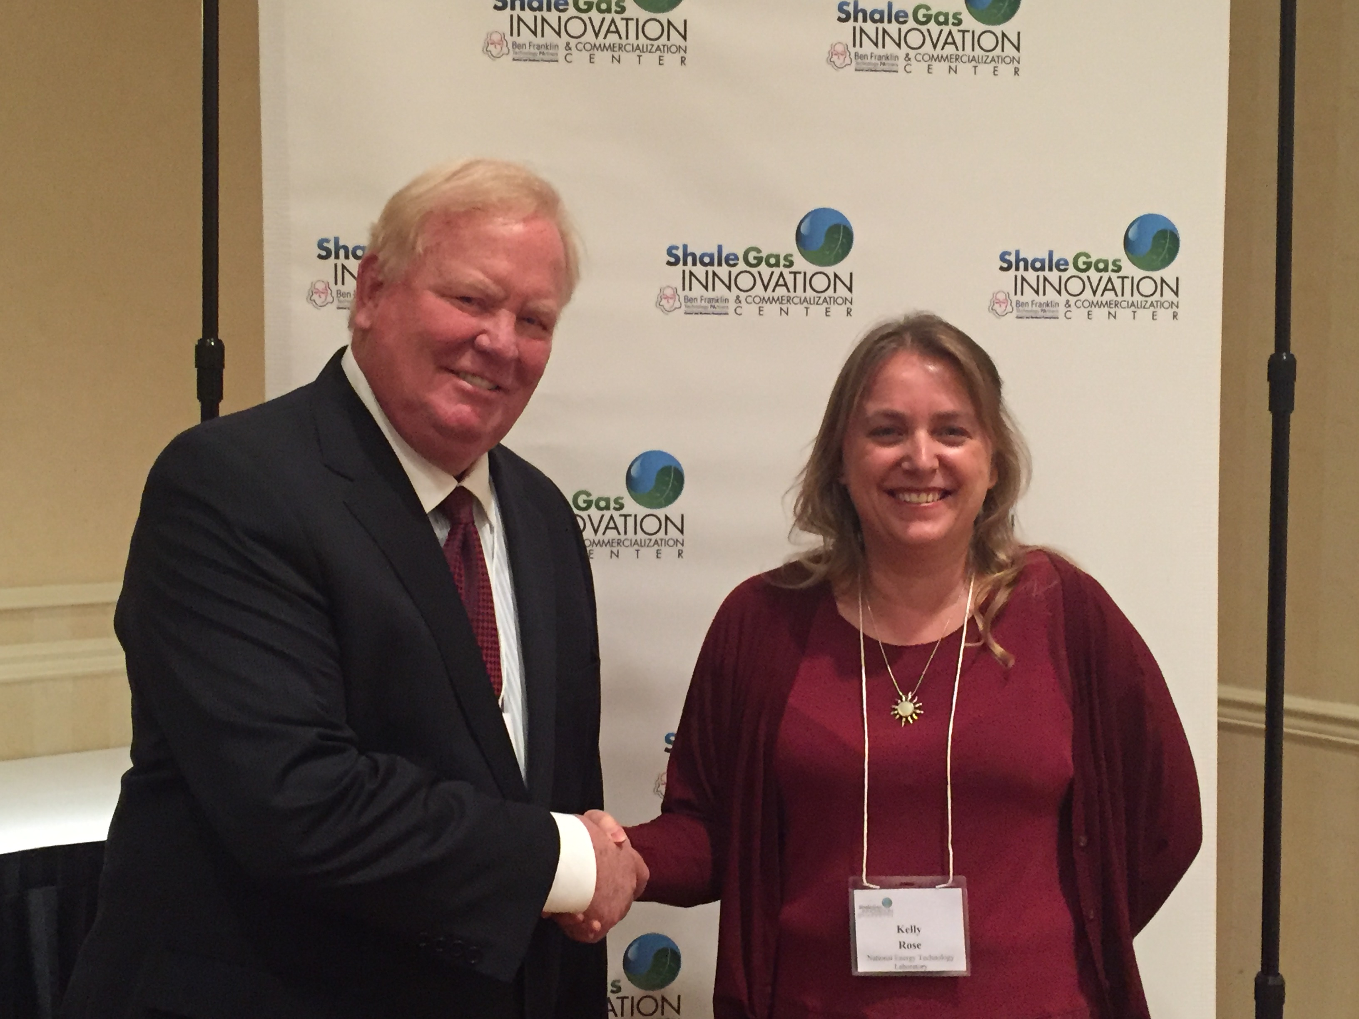
Kelly Rose, Technology Geology & Geospatial Researcher from the DOE’s National Energy Technology Laboratory (NETL) is congratulated by Bill Hall, SGICC Director on being named the winner of the contest’s Innovative R&D Award
Regarding the overall event, Bill Hall, Ben Franklin SGICC Director noted, “All of the finalists again displayed the diversity of ideas being brought forward by regional entrepreneurs and small companies. Continuous innovation is advancing every aspect of how the oil and gas industry operates, and uncovering these novel technologies is exactly what the Shale Gas Innovation Contest is all about.”
Loren Anderson, Director Technical Affairs at the Marcellus Shale Coalition, a contest sponsor and event judge commented, “Every year the Innovation Contest provides a platform for new technologies that are ready for deployment. With an ever changing and fast paced industry, these technologies provide solutions and improvements for our member’s operations in the Appalachian Basin.”

Tim Miller, Engineering Manager at Frontier Natural Resources commented, "We are honored to be recognized by the SGICC Shale Gas Innovation Contest as a 2017 Contest Winner. We value our relationship with SGICC and their encouragement of valuable innovations that continue to improve the safety and efficiency of the shale gas industry. We look forward to continuing to provide affordable and clean energy to all industries across Pennsylvania."

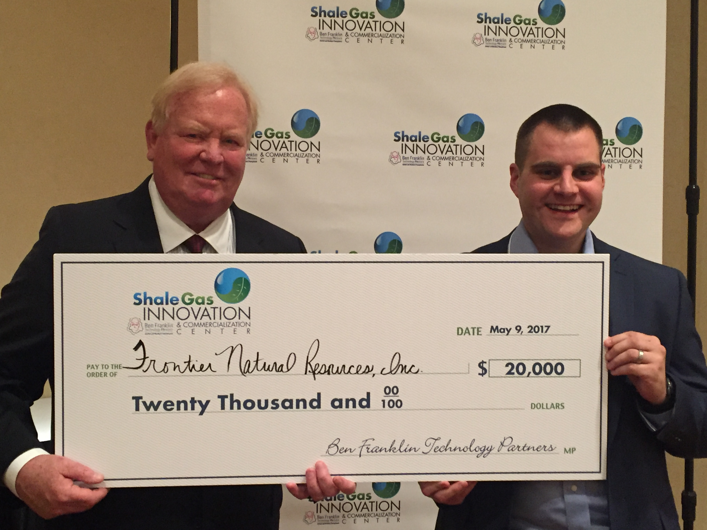
Tim Miller, Engineering Manager at Frontier Natural Resources accepts
Winner’s Check. Also pictured are Bill Hall, SGICC Director

Earl Drake, VP of Business Development at Petromar Technologies, Inc. noted, “I truly believe the SGICC as well as the MSC and your other sponsors/stakeholders have created and continue to foster a highly functioning 'innovation ecosystem' in this region. That's really cool to see, as the Marcellus/Utica transitions from not only a market for O&G technology but also a significant source of such technology. Good stuff!”

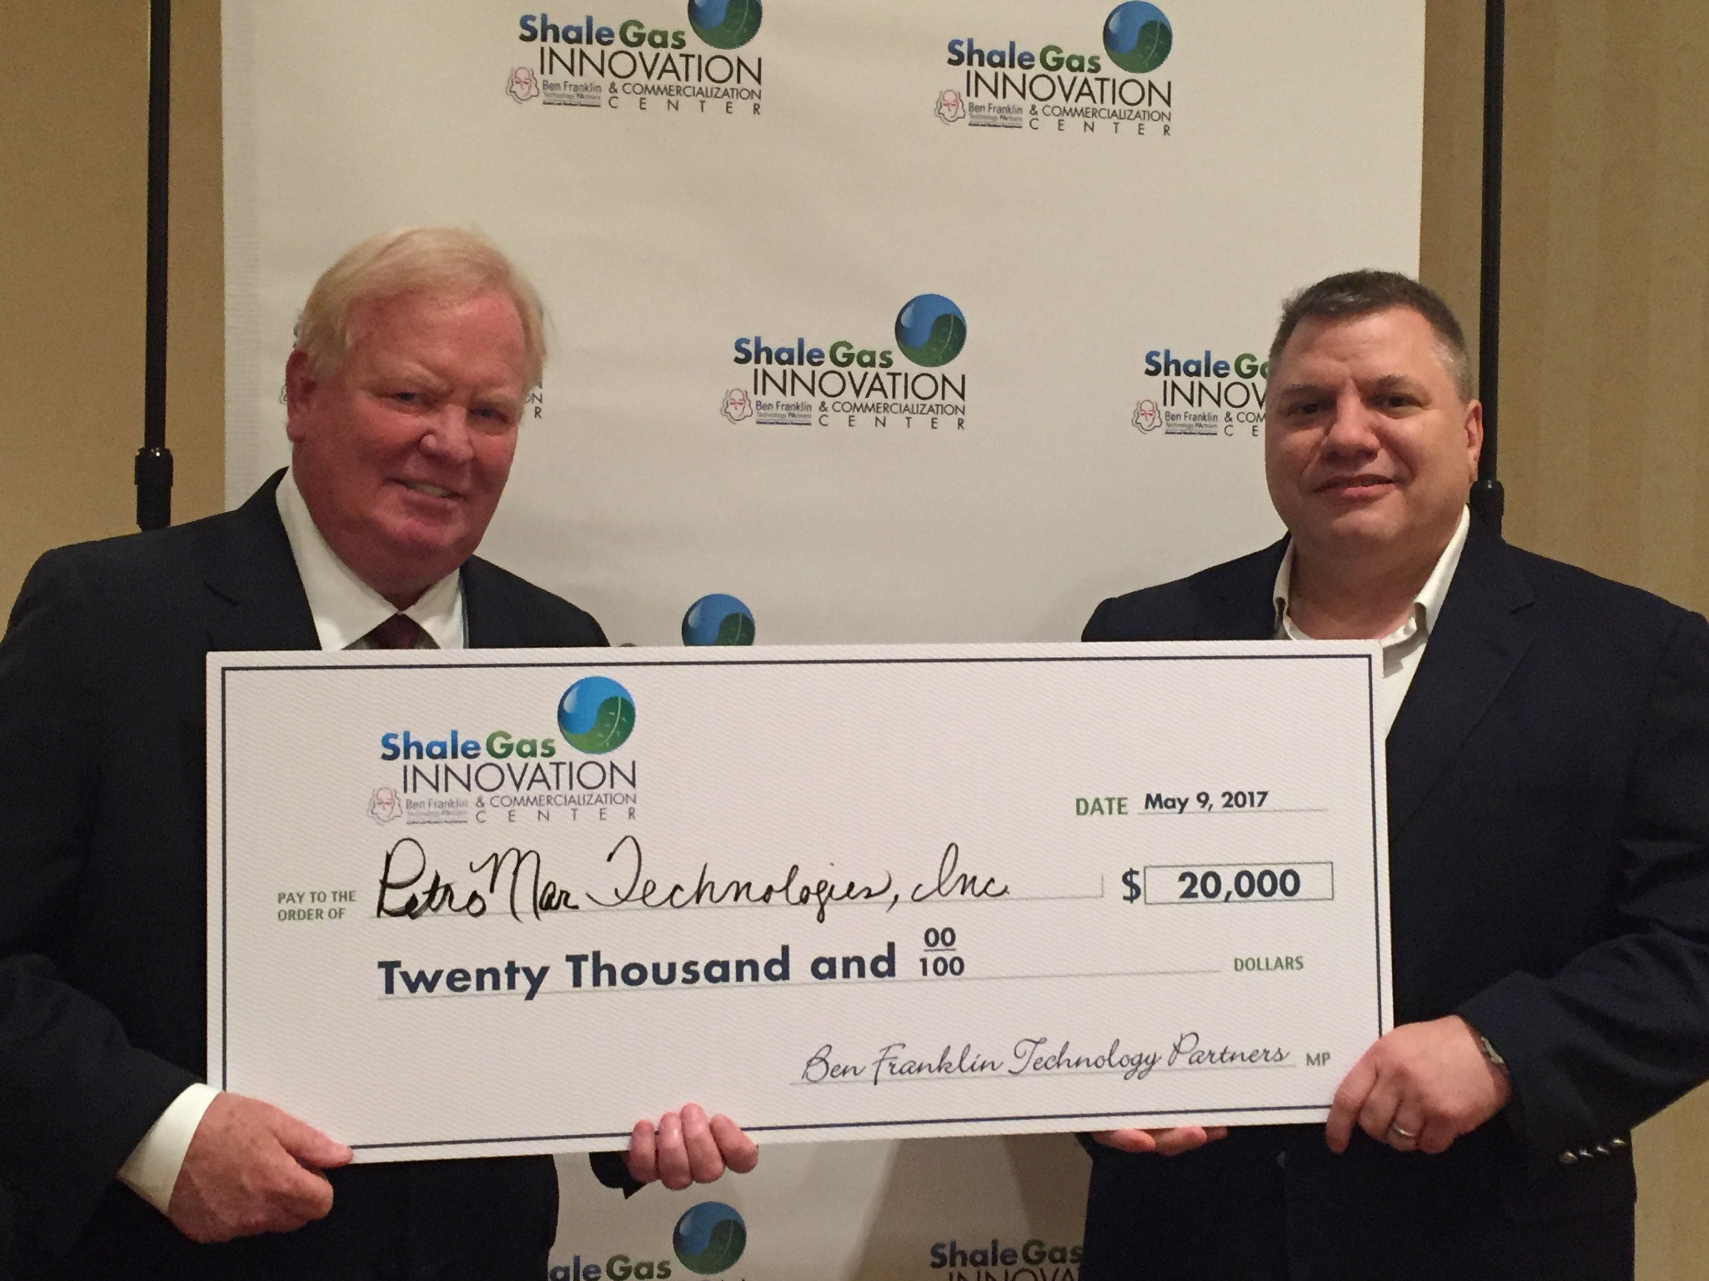
Earl Drake (on right), VP of Business Development at Petromar Technologies, Inc.
accepts Winner’s Check from Bill Hall, SGICC Director

Jim Barshinger, President of Sensor Networks, located in Boalsburg, PA noted, “We are honored that our submission “Wireless Corrosion Monitoring of Oil and Gas Infrastructure” has been recognized as a winner of the 6th Annual Shale Gas Innovation Contest. Working with the Shale Gas Innovation and Commercialization Center and Ben Franklin Technology Partners provides both important early-stage funding opportunities for technology startups like SNI and also invaluable opportunities to present our technologies to key industry managers and decision makers. We are continually impressed with the breadth and depth of technologies on display at the Shale Gas Innovation Contest and would like to extend our gratitude to the judges, contest organizers and our fellow competitors.”

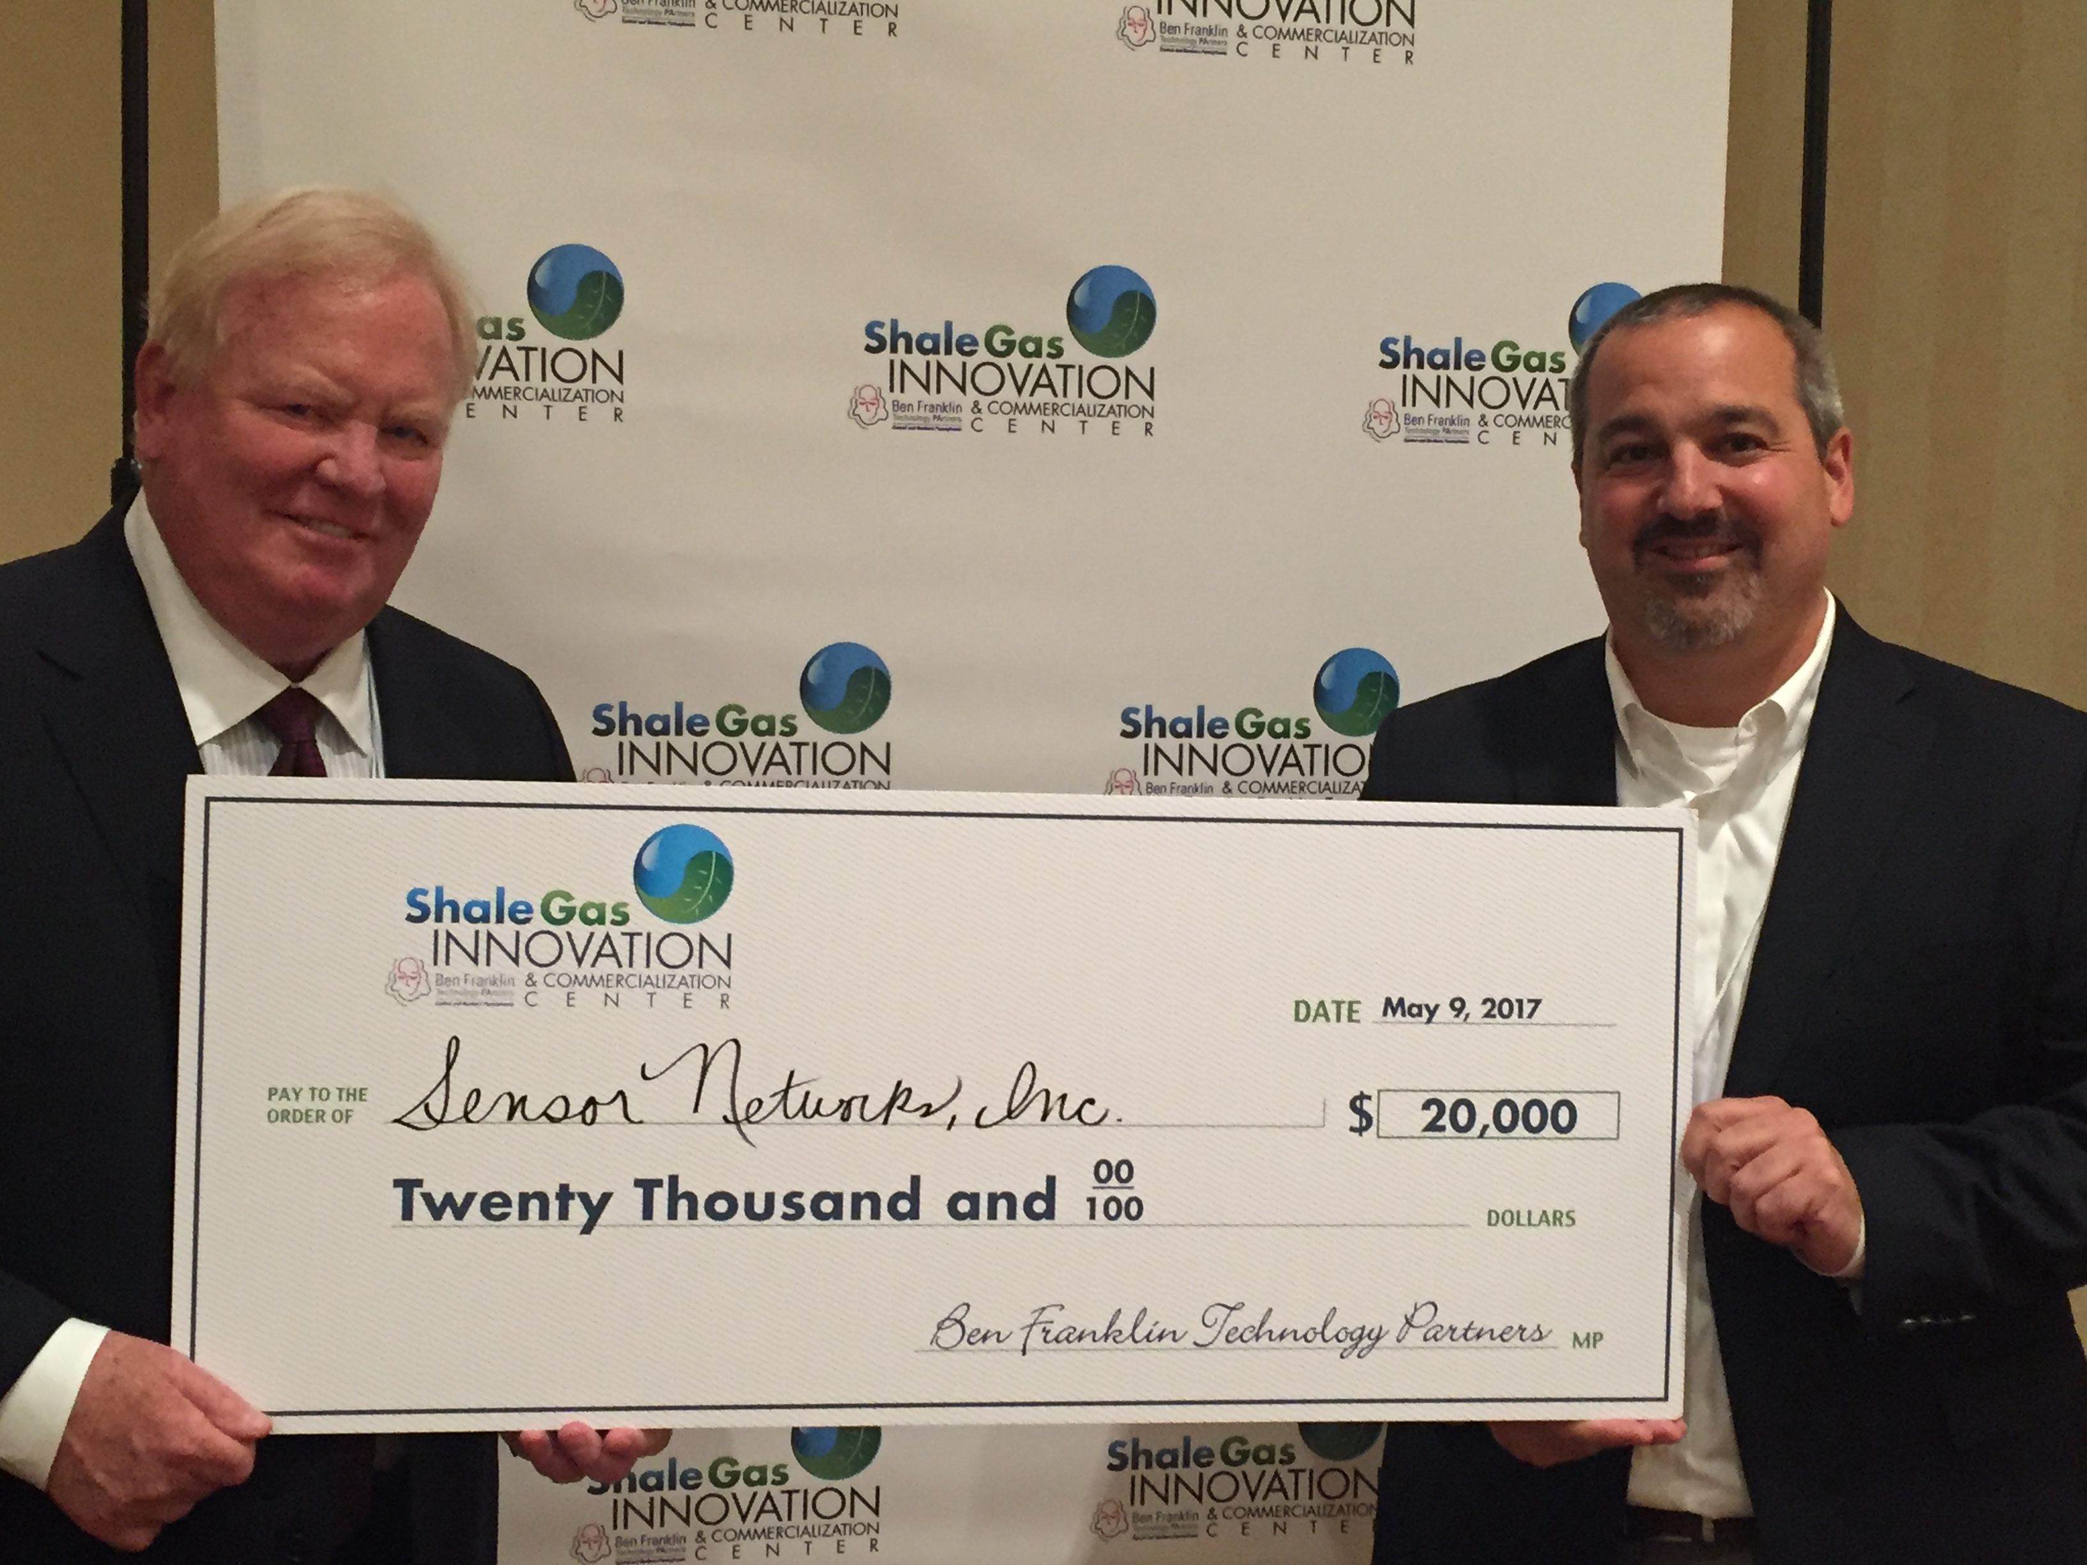

Jim Barshinger (on right), President of Sensor Networks, Inc. accepts
Winner’s Check from Bill Hall, SGICC Director

At the event two winners were also announced for posters presented by students from CMU and Penn State. The winners were:
- Cold Energy Recovery from LNG Regasification, submitted by Nyla Khan, M.S. Civil & Environmental Engineering, Carnegie Mellon University ; and,
- Fast and Robust Pattern Recognition for Re-Stimulation Candidate Selection using Subsurface Big Data, submitted by Eddie Udegbe, PhD Candidate, Department of Energy and Mineral Engineering, The Pennsylvania State University
Finalist presentations and additional details on the event are posted at http://www.sgicc.org/2017-shale-gas-innovation-contest.html.

This 6th Annual Shale Gas Innovation Contest’s GOLD Sponsor was the Ben Franklin Technology Partners. Industry sponsors included: AquaTech, Chevron Technology Ventures, EQT Corporation, Fluid Recovery Systems, LPR Energy, LPR Land Services, the Marcellus Shale Coalition, Praxair, Range Resources, Steptoe & Johnson PLLC, and Williams. Non-Profit sponsors included: Carnegie Mellon University’s Scott Institute for Energy Innovation, and the Penn State University’s Institute for Natural Gas Research.
About the SGICC
The Ben Franklin Shale Gas Innovation and Commercialization Center (www.sgicc.org) supports and commercializes early-stage technologies that enhance responsible stewardship of the environment while properly utilizing this energy asset.

