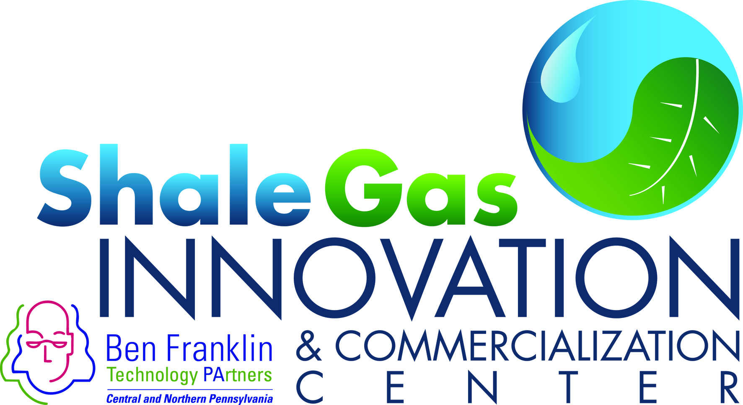
FOR IMMEDIATE RELEASE April 05, 2016
For further information:
Bill Hall/ Director
Shale Gas Innovation & Commercialization Center
814-933-8203
billhall@psu.edu

2016 Shale Gas Innovation Contest Finalists Named!

STATE COLLEGE, PA - On May 18, 2016, the Shale Gas Innovation & Commercialization Center (www.sgicc.org) will announce four $20,000 winners of this year’s Shale Gas Innovation Contest. In addition to showcasing the 12 finalists, this year’s Final’s Event will also feature a Poster Contest highlighting research under way related to the oil and gas sector at four major regional research universities.

The Final’s Event will be held from 1:00PM to 5:00 PM followed by a reception on Wednesday, May 18th at the Hilton Garden Inn in Southpointe, PA. Attendees at this FREE EVENT will hear from Bill Hall, SGICC Director, followed by a keynote address by Joe Frantz, Vice President of Engineering/Marcellus Shale Division of Range Resources Corporation.

Regarding Range Resource’s Innovation strategies, Mr. Frantz noted, “Range’s operational team continues to be creative and efficient in how we do our work, ranging from small steps to large scale changes to help reduce costs. Last year alone, Range saw drilling costs drop by 21% per lateral foot, combined with a 33% reduction in completion costs.” Mr. Frantz’s address will focus on Range’s key drivers in well cost reductions and the application of technology to improve overall performance.

The Poster session will feature research being undertaken at Carnegie Mellon University, Penn State, the University of Pittsburgh, and West Virginia University. Attendees at this year’s Final’s Event will also hear from a panel of three previous contest winners. Each will provide an update regarding the exciting progress they have made toward supporting critical challenges faced by the shale energy industry.

The main event of the afternoon will consist of the 12 finalist presentations and the announcement of the four Innovation Contest winners. A networking reception will follow immediately with representatives from each of the finalists, poster presenters, panel companies, and additional exhibitors available to highlight their shale energy innovation concepts. Click on http://www.sgicc.org/finals-event-2016-shale-gas-innovation-contest.html to register and to see additional information regarding this year’s event.

This year’s Finalists are:
- AccuCore Technologies
Developing a product capable of recovering and retaining in-situ conditions in a 30 foot core that is 3 1/2” in diameter with up to 12,000 psi of reservoir pressure. This allows the core to be processed at the surface to gather total gas and liquids volume measurements and be sent to core labs for more detailed analysis.
- Aridea Solutions
Developing an on-demand pneumatic actuated valve system operated through a proprietary software interface via the internet (IoT) which allows remote control at hard to access midstream sites.
- Compass Natural Gas
Building compression stations to access significant volumes of natural gas to produce CNG for delivery via truck/trailer to small through large industrial, transport, agricultural, commercial, municipal, and other customers in the region that currently don’t have access to pipeline NG.
- EKU Power Drives
Providing a natural gas - electric hybrid solution (NG engines, e-motors, battery and power electronics in a single powertrain unit) that relies on a proprietary power pattern prediction software platform. This solution optimizes operations and increases the asset life while facilitating electrification in off-grid industrial applications for pressure pumping applications.
- Epiphany Water Solutions
Providing a well pad based hybrid powered (solar, NG, or hard-wired) water remediation solution housed in 20 ft. shipping containers that uses a proprietary crystallizing chamber where all of the contaminants in the water drop out, leaving pure steam that can be further evaporated for zero discharge.
- HalenHardy, LLC
The SPILLTRATION™ product line, made from post-consumer and post-industrial materials, is engineered to absorb and contain oil-based leaks and spills while allowing clean water to filter through. This also allows for the products to be reused after oil is removed for recycling.
- Intelligent Solutions
Shale Production Optimization Technology (“SPOT”) is a data-driven modeling and optimization technology that uses production data to analyze, model, and optimize oil and gas production through better completion (stage length, number of stages, etc.) and hydraulic fracturing (amount and the rate of fluid and proppant injection, etc.) practices.
- Mnergy Corporation
Unique virtual natural gas pipeline concept that utilizes a novel, patented mobile front-end reactor system. The system converts natural gas in to a solid NG-H2O mix, capturing the solid in a pellet form in tanks that will be transported to off-pipeline customers. The pellets will be turned back to CNG in the same delivery tank via a re-gasification process.
- North Shore Energy Services
“The Brine Box” is a modular treatment system housed in a 45 ft. shipping container which is capable of treating up to 2500BPD of frac/produced water without adding chemicals. The system removes suspended solids, hydrocarbons and scale factors to produce clean brine that has been used to frac without dilution with fresh water.
- PULS, Inc.
By collaborating with multiple equipment manufacturers, the company custom built an all-terrain utility vehicle that has equipment mounted to its frame allowing the exact location/ mapping of pipelines (capturing GPS location data) and simultaneously completing initial leak detection surveys.
- Sensor Networks
Developed flexible and scalable permanently installed ultrasonic sensor system that utilizes IoT communications. The network also provides remote access to high accuracy wall thickness or corrosion rate measurements in a wide range of customer apps, including high-temp zones, underground pipelines, and code-mandated inspection points in refineries, chemical plants, etc.
- Technology Commercialization Corp.
Developed polymer extruded production tubing with multiple small, internal round passageways of equal diameter. This a multi-channel production string, or “MCS” is specifically designed for transporting multi-phase flow, reducing by up to ten times the minimum gas velocity needed to maintain steady state flow up the well, avoiding/ forestalling liquid loading and increasing ultimate recovery at low cost.

This 5th Annual Shale Gas Innovation Contest’s GOLD sponsor is the Ben Franklin Technology Partners (http://www.benfranklin.org). Industry sponsors include: Chevron Technology Ventures (http://www.chevron.com/ctv/ctvi/), EQT Corporation (https://www.eqt.com), First National Bank (www.fnb-online.com), GE Transportation (http://www.getransportation.com/), LPR Energy (http://www.lprenergy.com/), LPR Land Services (http://www.lprls.com/), the Marcellus Shale Coalition (http://marcelluscoalition.org), PPG Industries (http://corporate.ppg.com/), Praxair (www.praxair.com), Steptoe & Johnson PLLC (http://www.steptoe-johnson.com/ ), and Williams (www.williamsinthenortheast.com). Non-Profit sponsors include: Carnegie Mellon University’s Scott Institute for Energy Innovation (http://www.cmu.edu/energy/), Penn State University’s Institute for Natural Gas Research (http://www.ems.psu.edu/INGaR), the University of Pittsburgh’s Center for Energy (http://www.engineering.pitt.edu/cfe/), and West Virginia University’s Energy Institute (http://energy.wvu.edu/). And the Media sponsor for this year’s event is the Marcellus Business Central (http://www.pabusinesscentral.com/).

About the SGICC
The Ben Franklin Shale Gas Innovation and Commercialization Center (www.sgicc.org) supports and commercializes early-stage technologies that enhance responsible stewardship of the environment while properly utilizing this energy asset.

